**PROJECT DESIGN PHASE-I**

**FUNCTIONAL REQUIREMENTS DOCUMENT**

| Date | 08 October 2022 |
| --- | --- |
| Team Lead | Febia Thomas |
| Team Members | Aryan TSB  Girish Kumar S  Madhav Hari V |
| Project Name | Early Detection of Chronic Kidney Disease using Machine Learning |

1. **GENERAL**
   1. **PROBLEM STATEMENT**

Chronic Kidney Disease (CKD) is a major medical problem and can be cured if treated in the early stages. Usually, people are not aware that medical tests we take for different purposes could contain valuable information concerning kidney diseases. Consequently, attributes of various medical tests are investigated to distinguish which attributes may contain helpful information about the disease. The information says that it helps us to measure the severity of the problem and we make use of such information to build a machine learning model that predicts Chronic Kidney Disease. CKD is more common in people aged 65 years or older (38%) than in people aged 45–64 years (12%) or 18–44 years (6%). CKD is slightly more common in women (14%) than men (12%).

* 1. **PROPOSED SOLUTION**

Data is collected and made in a common csv format.This data is then loaded, preprocessed inorder to remove null values, segregate the dependent and independent variables, encode the needed columns, create analysis maps, split the data into training and testing data, choose the model which can suit this problem, train the model with the training data, test the accuracy with the test data against predicted data and save the model to integrate it with a web app. A web app is built which renders a form for the user to enter the attributes.The saved model is loaded and the entered values are fed into the loaded model and the predicted results are returned to the user. The model is then deployed into the cloud for the web app to request from the deployed model.

1. **CONTEXT DIAGRAM**

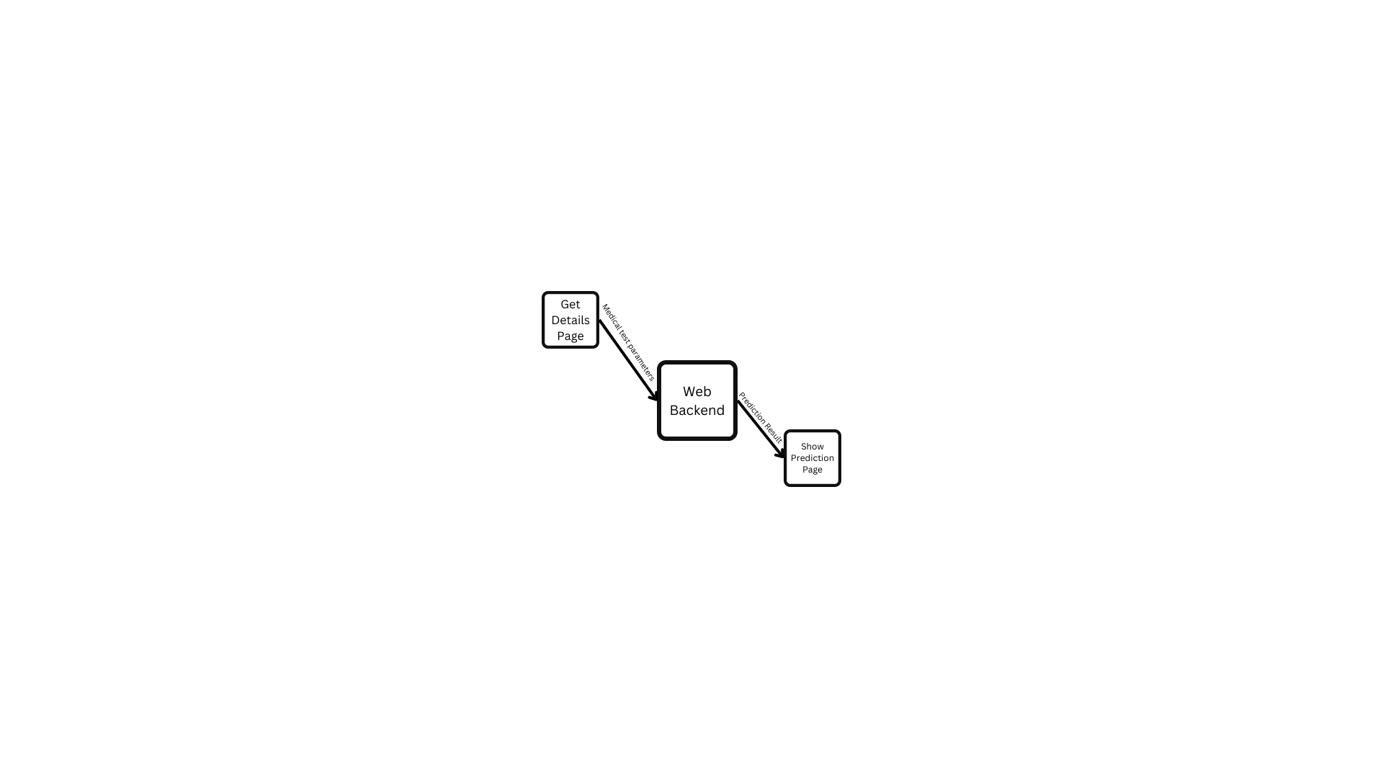

1. **DATA FLOW DIAGRAM**

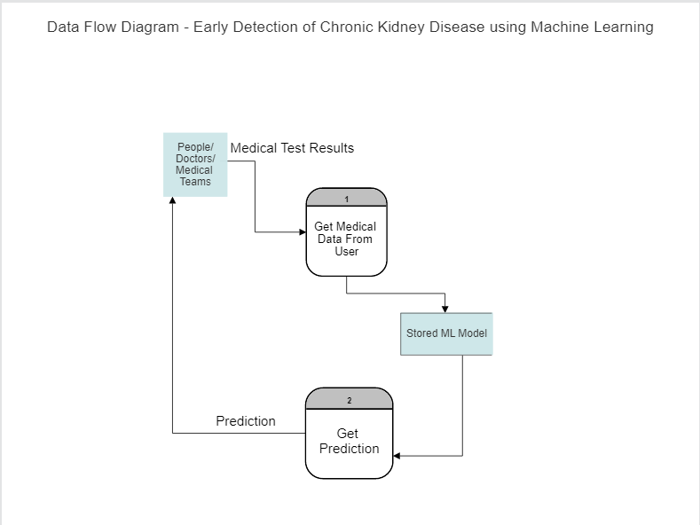

1. **FUNCTIONAL REQUIREMENTS**

| **REQUIREMENT ID** | **REQUIREMENT DESCRIPTION** |
| --- | --- |
| 1 | Users should be able to see the form in which they enter the medical test result values such as blood glucose level, blood urea level, RBC level, Anemia level etc when they enter the home url. |
| 2 | Users should be able to submit the form with all the necessary attributes filled and should be appropriately notified when some values are missing. |
| 3 | The app should accept the test values and feed those inputs into the pre-saved trained machine learning model and should return the prediction result. |
| 4 | The app should redirect the users to the appropriate page based on the prediction result. |